# Sri Lanka Institute of Information Technology

# SE3050 – User Experience Engineering

# Milestone 06: User Feedback for Prototype

**Group:** Native Coders



IT21118340 Kumarathunga S. A. D. S.

IT21291364 Rashen W.G.M

IT21267772 Kumanayake I. A.

IT21388934 Siriwardhana S.M.R.R.

**Participant Profiles**

The table below provides a breakdown of the participants selected for video interview:

|  |  |  |
| --- | --- | --- |
| **Name** | **Demography** | **Date & Time** |
| Sathsarani Wijeratne | * Undergraduate * Between age under 20 - 25 * Student at SLIIT. * Specialization in Software Engineering. | 2023-09-20 18.30 |
| Sasini Nimesha | * Undergraduate * Between age under 20 - 25 * Student at KDU. * Specialization in Software Engineering. | 2023-09-22 18.30 |
| Rosara Dayaratne | * Undergraduate * Between age under 20 - 25 * Student at SLIIT. * Specialization in Software Engineering. | 2023-09-23 10.30 |
| Dananjaya Siriwardhana | * Undergraduate * Between age under 20 - 25 * Student at SLIIT. * Specialization in Data Science. | 2023-09-21 18.30 |

**Interview**

Interview Video Link

**Link:** <https://drive.google.com/drive/folders/1It7_XEsuAzOBSU0OnGVB_mGOKA-zAMH2?usp=drive_link>

## Transcripts

## Interview 01

**Video Link**: <https://drive.google.com/file/d/1wOm5RJo3WOZa0FkfvND0jR4Mp4NLRahe/view>

**Participant**: Dananjaya Siriwardhana

**Description**: 4rd year Data Science student

**Role**: Tutor

**Duration**: 0.5 hour

**Transcript:**

Team Member - Dilru: Hey Dananjaya ayye, Thank you for participating in this interview. So as u already know, We're developing an app that will help university students connect with tutors. So in this interview we are going to show u our prototype app and then u have to give us feedback about the app as u use it. U ready?

Interviewee - Dhananjaya: Yes. Let's start.

Team Member - Rumesh: So this is a prototype of our app. As soon as we open the app, we can see the splash screen. After a few seconds, it will redirect to the login page. If you are a new user, you can press the signup link at the bottom of the screen. From that page, you can select the sign-up option. Then you should fill out this form to sign up. After pressing the signup button, you will be directed to the login page. After the login, your home screen will open. On the home screen, you can see a banner slider, the most popular tutor list, and the most popular study materials. The navigation session is visible at the bottom of the screen. First navigation for the search option. From there, you can find a tutor or filter by category. By clicking on a tutor card, you can navigate to the full tutor information page. From here, you can see tutor academic information, ratings, what classes the tutor conducts, tutor expertise, and reviews. By pressing on one class, you can see whole-class information, including price and available session times. By pressing the booking button, you can navigate to the booking page. After filling out the form, you can click on the book button. Then notifications will appear. Second navigator for viewing study materials. From there, you can see search options, categories, and the most downloaded study materials. By clicking on a category, you can view study materials that are related to that category. You can download the note by pressing the download button. If you want further information, you can click on the material card. last navigator for the user account. You can edit your profile, view your classes, and logout. In My classes, you can see the status of the class. If the class is accepted, you can make the payment. You can open the payment gate by clicking the pay button. Finally, you can logout form the application. By clicking the log-out button, the application requests confirmation. If you do not need to log out, you can cancel. If you want to log out, you can click logout. It will redirect to the login page.

Interviewee - Dhananjaya: So, the app seems to be geared towards both university students. One feature I really like, is how it helps in organizing classes. You can schedule, reschedule, and keep track of your classes easily. This feature alone saves a lot of trouble for me.

Interviewee - Dhananjaya: Another great thing is how students can easily find and contact tutors. The search functionality seems pretty good. You can filter tutors by subject, availability, and even ratings. So, It's a big time-saver for them.

Interviewee - Dhananjaya: And also tutors can get feedback from students. This will help tutors improve thier teaching style and It adds a layer of trust and transparency to the whole process.

Interviewee - Dhananjaya: Another feature I really like is the easier payment process. You can handle payments within the app, making it convenient and secure. No need for cash or worrying about payment logistics.

Interviewee - Dhananjaya: Finally, the option to share old notes and lecture slides directly through the app is fantastic. It fosters a sense of community and collaboration among students. I can see it being really helpful when preparing for exams.

Team Member - Manuka: That's great feedback. So, On a scale of 1 to 10, how likely would you be to use this app based on the features you've described?

Interviewee - Dhananjaya: I'd say around 9. It seems like a comprehensive solution that caters to the needs of both students and tutors. The only reason I'm not giving it a 10 is because I haven't seen the actual app in action yet.

Team Member - Rumesh: Thank you for your valuable input. Lastly, is there anything you think could be improved or added to make this app even better?

Interviewee - Dhananjaya: Well, The app looks really great. Although I have a small suggestion, Can u add a feature that will allow users to link our google account with the app? It will make it easier for user to register for the app.

Team Member - Dilru: Yes. We will definitely consider about it. Thank you so much for taking the time to do this interview. We genuinely appreciate it!

Interviewee - Dhananjaya: Thank you guys for having me. I wish you all the best.

## Interview 02

**Video Link**: <https://drive.google.com/file/d/10Fgh22GtTVcAPZxZuiwaEp0p8YYdCCmq/view>

**Participant**: Sathsarani Wijeratne

**Description**: 3rd year Software Engineering student

**Role**: Tutor

**Duration**: 0.5 hour

**Transcript:**

Team Member - Dilru: Hey Sathsarani akke, Thank you for participating in this interview. So as u already know, We're developing a mobile application that will help university students connect with tutors. So in this interview we are going to show u our prototype app and then u have to give us feedback about the app as u use it. And if u have any questions regarding the app, u can ask from Us. So r u ready?

Interviewee - Sathsarani: Yes. Let's start.

Team Member - Rumesh: So this is a prototype of our app. As soon as we open the app, we can see the splash screen. After a few seconds, it will redirect to the login page. If you are a new user, you can press the signup link at the bottom of the screen. From that page, you can select the sign-up option. Then you should fill out this form to sign up. After pressing the signup button, you will be directed to the login page.

Team Member - Rumesh: So that is all about the app. So do u have any questions or anything u want to clarify?

Interviewee - Sathsarani: No, Everything is clear.

Team Member - Dilru: Now, we're going to give you 3 tasks to do, and you just need to finish them and let us know what you think.

Team Member - Dilru: So the first task is to register for the app and create a class. the second task is to upload a study material. and third task is to make a withdrawal. And as u complete the process u can ask us any questions or speak your thoughts.

Interviewee - Sathsarani: << Completes the tasks >>

Interviewee - Sathsarani: Okay. Both tasks are completed.

Team Member - Isuru: Alright, now that you've tried out our prototype and finished some tasks on your own, do you have any thoughts or suggestions for us?

Interviewee - Sathsarani: So, aesthetic wise, App has nice UI. And I also like the color theme. Green is suitable color for educational app. As for app functionality, one thing I really like, is how easy it is to organizing classes. You can schedule, and keep track of your classes easily. Another feature I really like is the easier payment process. You can handle payments within the app, it is really convenient for busy people like me. And I also like that app has a feature to share old lecture notes. I'm sure that will be big help for lot of students.

Team Member - Manuka: That's great feedback. So, On a scale of 1 to 10, how likely would you be to use this app based on the features you've described?

Interviewee - Sathsarani: I'd say around 8. It seems like it is a really good app.

Team Member - Rumesh: Thank you for your valuable input. Lastly, is there anything you think could be improved or added to make this app even better?

Interviewee - Sathsarani: Yes, I have a one suggestion. It would be great if you could simplify the tutor registration process. I understand that you need a lot of information to to validate tutors. But, current process might feel a bit overwhelming to first time users, especially it they aren't tech-savvy. Maybe try dividing them into smaller sections, so users don't have to deal with a lot of questions, all at once.

Team Member - Dilru: Yes. We will definitely consider about it. Thank you so much for taking the time to do this interview. We genuinely appreciate it!

Interviewee - Sathsarani: Thank you guys for having me. I wish you all the best.

Interview 03

**Video Link**: <https://drive.google.com/file/d/1HvstrN0RfK90cpn0Su4S6jmJ5N0kGViB/view>

**Participant**: Sasini Nimesha

**Description**: 3rd year Software Engineering student

**Role**: Student

**Duration**: 0.5 hour

**Transcript:**

Team Member - Dilru: Hey Sasi, Thank you again for participating in this interview. So as u know, We're developing an mobile application that will help university students connect with tutors. First, we'll show you our app's early version and how it works. While we explain, please ask any questions or share your thoughts. After that, we'll give you a task and ask questions as you use the app. It's important to know we're testing the app, not you. There are no wrong answers. Feel free to tell us if you like or don't like something, if you're confused, or anything else. Are you ready?. So a r u ready?

Interviewee - Sasini: Okay. Let's start.

Team Member - Rumesh: So this is a prototype of our app. As soon as we open the app, we can see the splash screen. After a few seconds, it will redirect to the login page. If you are a new user, you can press the signup link at the bottom of the screen. From that page, you can select the sign-up option. Then you should fill out this form to sign up. After pressing the signup button, you will be directed to the login page. After the login, your home screen will open. On the home screen, you can see a banner slider, the most popular tutor list, and the most popular study materials. The navigation session is visible at the bottom of the screen. first navigation for the search option. From there, you can find a tutor or filter by category. By clicking on a tutor card, you can navigate to the full tutor information page. From here, you can see tutor academic information, ratings, what classes the tutor conducts, tutor expertise, and reviews. By pressing on one class, you can see whole-class information, including price and available session times. By pressing the booking button, you can navigate to the booking page. After filling out the form, you can click on the book button. Then notifications will appear. Second navigator for viewing study materials. From there, you can see search options, categories, and the most downloaded study materials. By clicking on a category, you can view study materials that are related to that category. You can download the note by pressing the download button. If you want further information, you can click on the material card. last navigator for the user account. You can edit your profile, view your classes, and logout. In My classes, you can see the status of the class. If the class is accepted, you can make the payment. You can open the payment gate by clicking the pay button. Finally, you can logout form the application. By clicking the log-out button, the application requests confirmation. If you do not need to log out, you can cancel. If you want to log out, you can click logout. It will redirect to the login page.

Team Member - Rumesh: So that is all about the app. So do u have any questions or anything u want to clarify?

Interviewee - Sasini: Yes, I've got a quick question. I noticed that some details from the booking page, like the reason or how many students, are missing on the payment page. Do you think it would be a good idea to include them on the payment page?

Team Member - Dilru: Now, we're going to give you 2 tasks to do, and you just need to finish them and let us know what you think. Is it easy or hard? Is there anything that could be made better? Okay?

Team Member - Dilru: So the first task is to register for the app, then you have to select a tutor and book a session with them. And the second task is to go to study material market place section and download a document. And as u complete the process u can ask us any questions or speak your thoughts.

The first task is to sign up for the app. then you have to login and book a session with a tutor. The second task is to visit the study material section and download a document. As you finish these task, you can ask us any questions. Okay?

Interviewee - Sasini: << Completes the tasks >>

Interviewee - Sasini: Okay. Both tasks are completed.

Team Member - Isuru: Alright, now that you've tried out our prototype and finished some tasks on your own, do you have any thoughts or suggestions for us?

Interviewee - Sasini: Yes, one thing I really appreciate is that we can quickly get in touch with tutors. We can also check their ratings and what other students say about them. Plus, I can see how much a session costs upfront, so I know what to expect. Also, being able to find and download old study notes and lecture slides on the app is great for studying. But I didn't see a way to write reviews. If you guys can add that, it would be awesome!"

Team Member - Manuka: That's great feedback. We'll work on adding a way for students to write reviews. So, On a scale of 1 to 10, how likely would you be to use this app based on the features you've described?

Interviewee - Sasini: I'd say around 9. It seems like a good app.

Team Member - Dilru: Thank you for your valuable input. And We genuinely appreciate u taking the time to do this interview.

Interviewee - Sasini: Thank you guys for having me. I wish you all the best.

Interview 04

**Video Link:** <https://drive.google.com/file/d/1lTJ53-lLUVK3R4zZT6rnV2klSJpfpAux/view>

**Participant**: Rosara Dayaratne

**Description**: 2rd year Software Engineering student

**Role**: Tutor

**Duration**: 0.5 hour

**Transcript:**

Team Member - Dilru: Hello Rosara, Thank you again for participating in this interview. So as u know, We're developing an mobile application that will help university students connect with tutors. First, we'll show you our app's early version and how it works. While we explain, please ask any questions or share your thoughts. After that, we'll give you a task and ask questions as you use the app. It's important to know we're testing the app, not you. There are no wrong answers. Feel free to tell us if you like or don't like something, if you're confused, or anything else. Are you ready?. So a r u ready?

Interviewee - Rosara: Yes. Let's start.

Team Member - Rumesh: So this is a prototype of our app. As soon as we open the app, we can see the splash screen. After a few seconds, it will redirect to the login page. If you are a new user, you can press the signup link at the bottom of the screen. From that page, you can select the sign-up option. Then you should fill out this form to sign up. After pressing the signup button, you will be directed to the login page. After the login, your home screen will open. On the home screen, you can see a banner slider, the most popular tutor list, and the most popular study materials. The navigation session is visible at the bottom of the screen. first navigation for the search option. From there, you can find a tutor or filter by category. By clicking on a tutor card, you can navigate to the full tutor information page. From here, you can see tutor academic information, ratings, what classes the tutor conducts, tutor expertise, and reviews. By pressing on one class, you can see whole-class information, including price and available session times. By pressing the booking button, you can navigate to the booking page. After filling out the form, you can click on the book button. Then notifications will appear. Second navigator for viewing study materials. From there, you can see search options, categories, and the most downloaded study materials. By clicking on a category, you can view study materials that are related to that category. You can download the note by pressing the download button. If you want further information, you can click on the material card. last navigator for the user account. You can edit your profile, view your classes, and logout. In My classes, you can see the status of the class. If the class is accepted, you can make the payment. You can open the payment gate by clicking the pay button. Finally, you can logout form the application. By clicking the log-out button, the application requests confirmation. If you do not need to log out, you can cancel. If you want to log out, you can click logout. It will redirect to the login page.

Team Member - Rumesh: So that is all about the app. So do u have any questions or anything u want to clarify?

Interviewee - Rosara: No, Everything is clear.

Team Member - Dilru: Now, we're going to give you 3 tasks to do, and you just need to finish them and let us know what you think. And as u complete the process u can ask us any questions or speak your thoughts.

Team Member - Dilru: So the first task is to register for the app and create a class. Please let us know once u complete the task. Can u share ur screen?

Interviewee - Rosara: first task is completed.

Interviewee - Rosara: << Completes the task the task >>

Team Member - Dilru: Okay, The second task is to upload a study material.

Interviewee - Rosara: << Completes the task >>

Interviewee - Rosara: second task is completed.

Team Member - Dilru: third task is to make a withdrawal.

Interviewee - Rosara: << Does the task >>

Interviewee - Rosara: third task is completed.

Team Member - Isuru: Alright, now that you've tried out our prototype and finished some tasks on your own, do you have any thoughts or suggestions for us?

Interviewee - Rosara: So, design wise, App has a nice UI. and As for app functionality, one thing I really like, is how easy it is to organizing classes. Another feature I really like is the easier payment process. You can handle payments within the app, it is really convenient. And I also like that app has a feature to share old lecture notes. It will be big help for lot of students.

Team Member - Manuka: That's great feedback. So, On a scale of 1 to 10, how likely would you be to use this app based on the features you've described?

Interviewee - Rosara: I'd say around 9. It seems like it is a really good app.

Team Member - Rumesh: Thank you for your valuable input. Lastly, is there anything you think could be improved or added to make this app even better?

Interviewee - Rosara: Yes, I have a some suggestions. If u can consider adding a single main category for documents instead of using tags, that might be better. If you could modify the color of the price tag on the Classes page, it would improve clarity of the UI.

Team Member - Dilru: Yes. We will definitely consider about it. Thank you so much for taking the time to do this interview. We genuinely appreciate it!

Interviewee - Rosara: Thank you guys for having me. I wish you all the best.

## Questionnaire

**For Tutors**

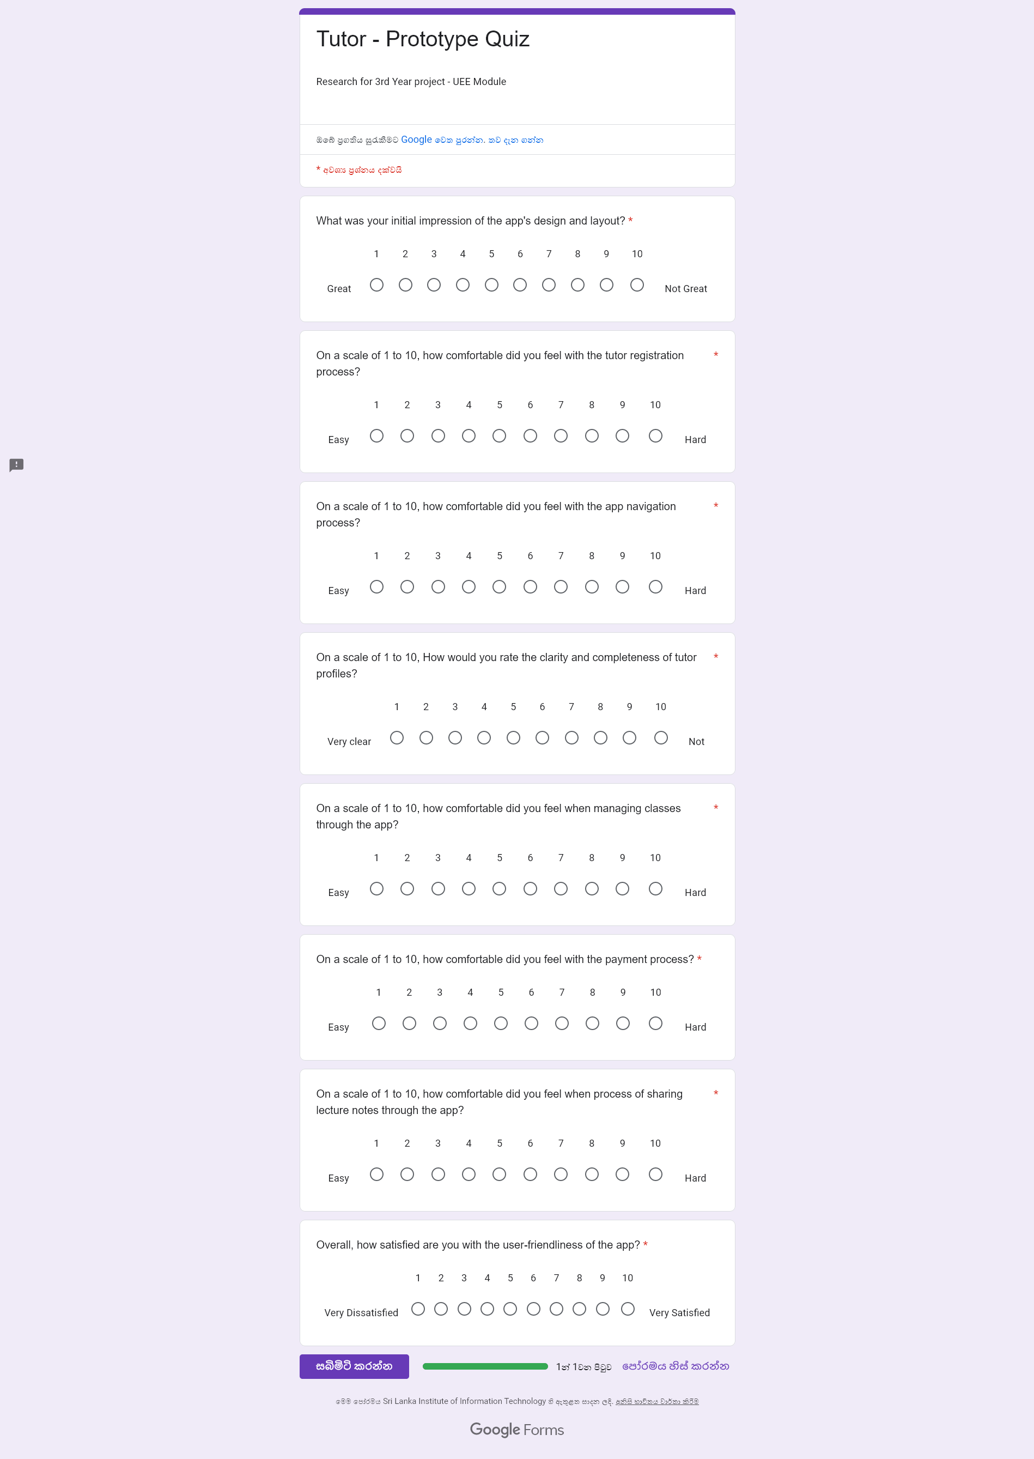

**For Students**

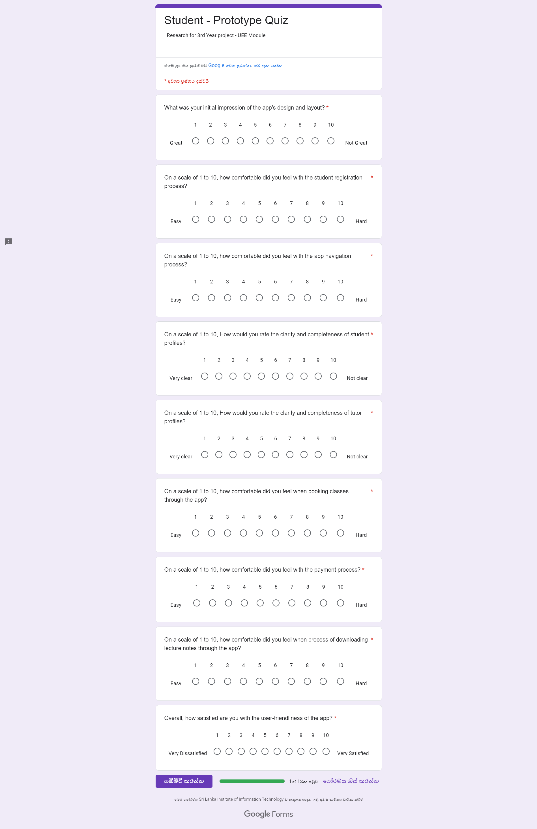

**Plan for Data Analysis**

## Questionnaire results

**For Tutors**

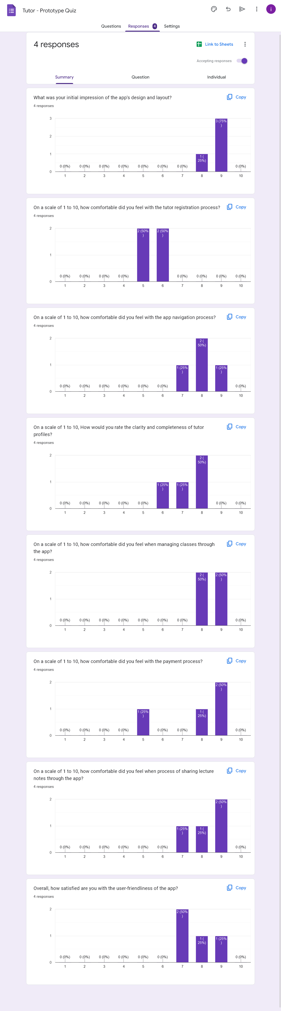

**For Students**

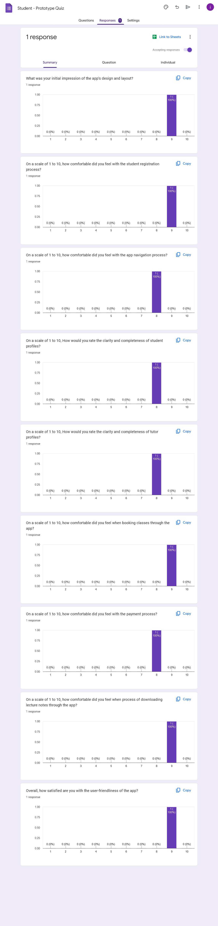

## User Requests

* Simplify the tutor registration process
* One category for documents instead of using tags
* Improve the functionality to calendar component.
* Added extra Information is to the payment page
* Remove decline, accept and send info button, to reduce the complexity and prevent accidental touch.

**Complete Prototype -Version 02**

Link: <https://www.figma.com/file/Usv4uPDQUBHi0N4bQVU3cG/TutorMe-(Version2)?type=design&mode=design&t=CKLuP4SFwCJChV6U-1>

**Modifications Based on User Feedback**

## IT21118340

**Modification 01:**

* Included a main category for book for study materials instead of tags, based on the suggestion of interviewed user.

**Modification 02:**

* Changed style of the header for all the pages related to Study materials. For consistency.

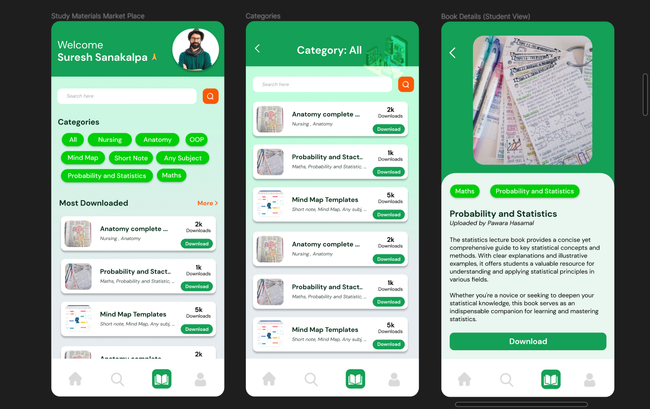**Version 01**

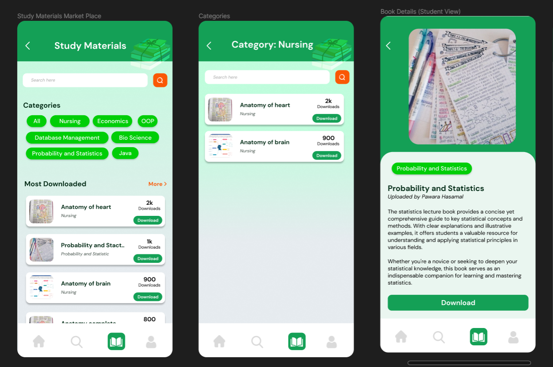**Version 02 (Modified Version)**

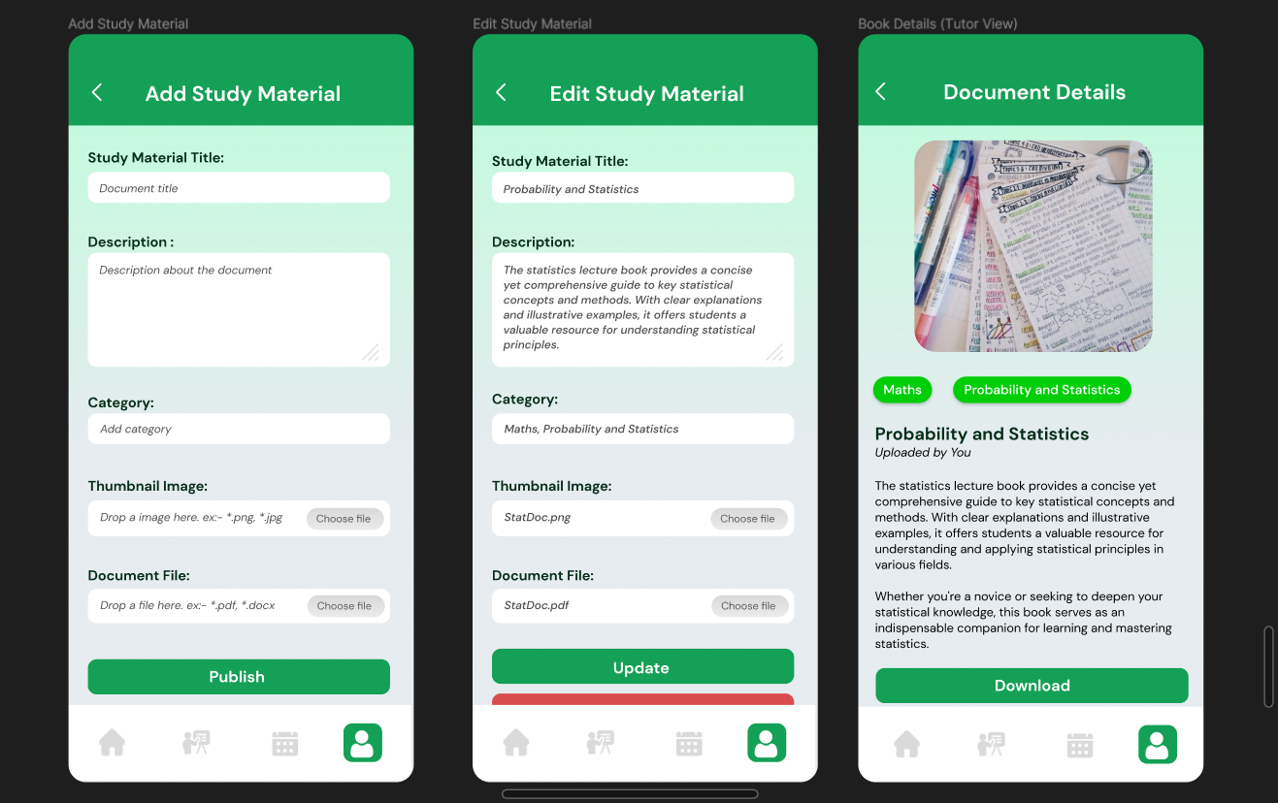**Version 01**

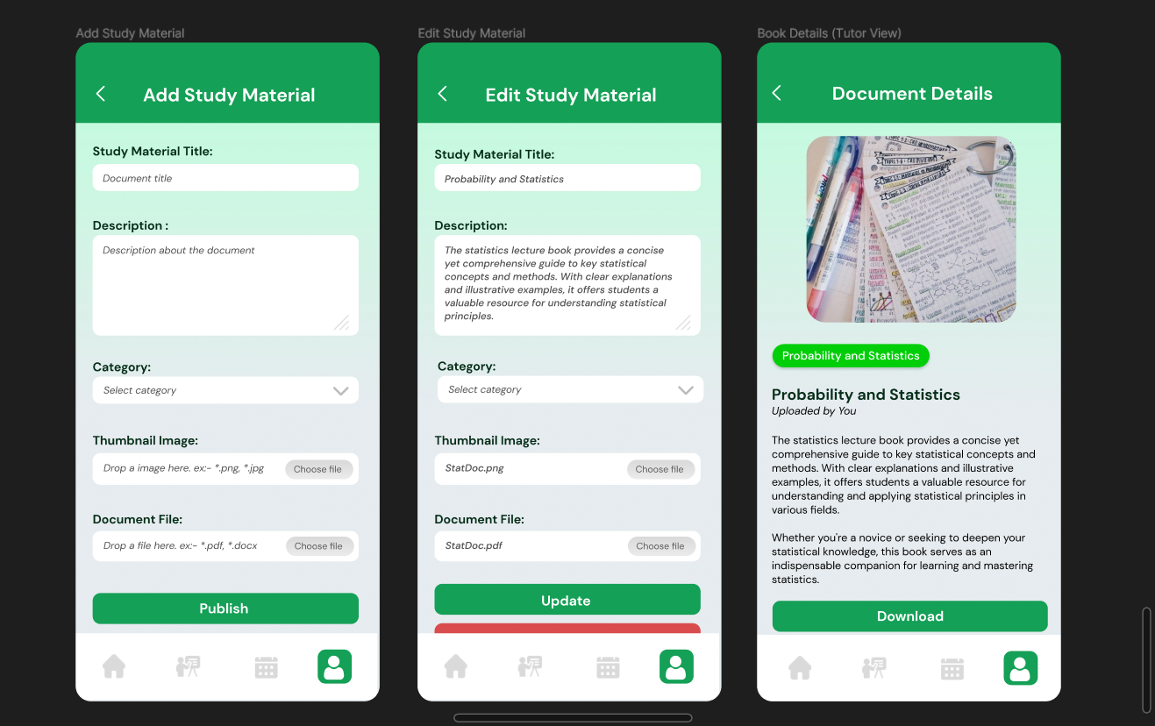**Version 02 (Modified Version)**

## IT21291364

**Modification 01:**

* Divided registration in to several processes, based on the suggestion of interviewed user.

**Version 01**

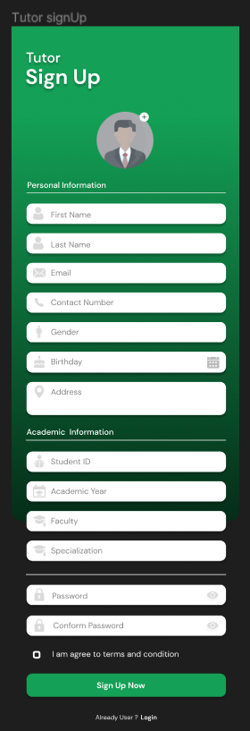

**Version 02 (Modified Version)**

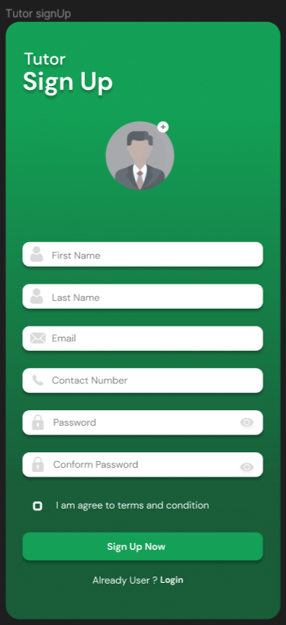

**Version 02 (Modified Version)**

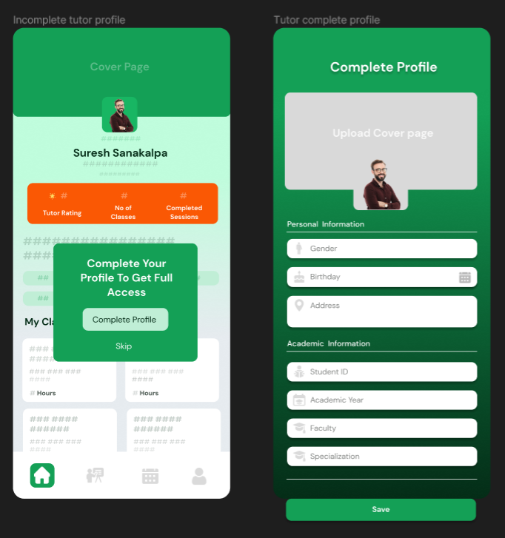

**Modification 02:**

* Improve the functionality to calendar component. Included the feature to change schedule.

**Version 01**

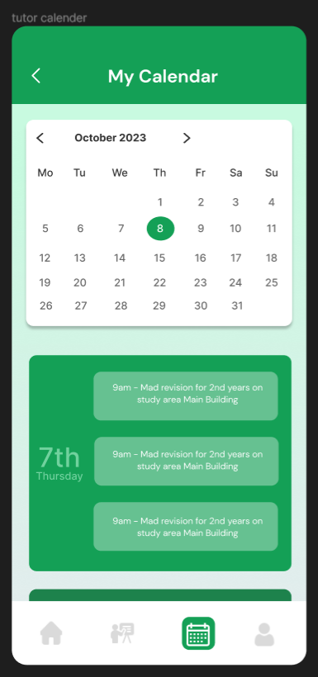

**Version 02 (Modified Version)**

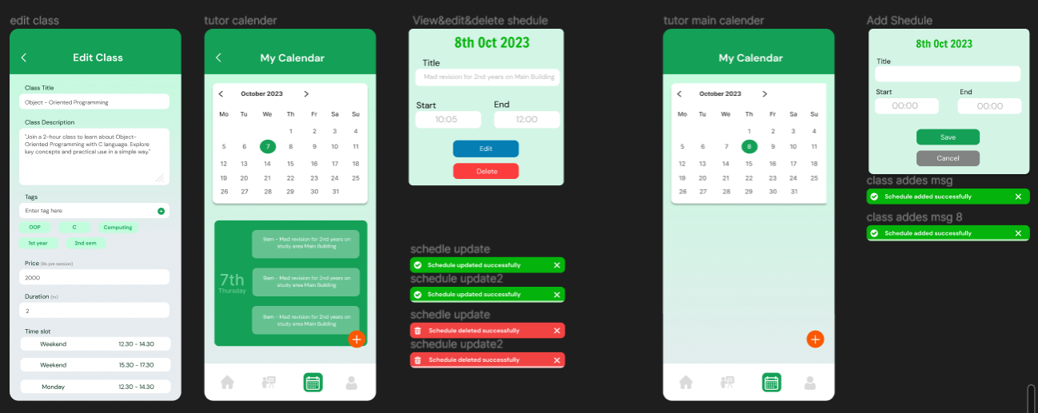

## IT21267772

**Modification 01:**

* Added extra Information is to the payment page, based on the suggestion of interviewed user.

**Version 01 Version 02 (Modified Version)**

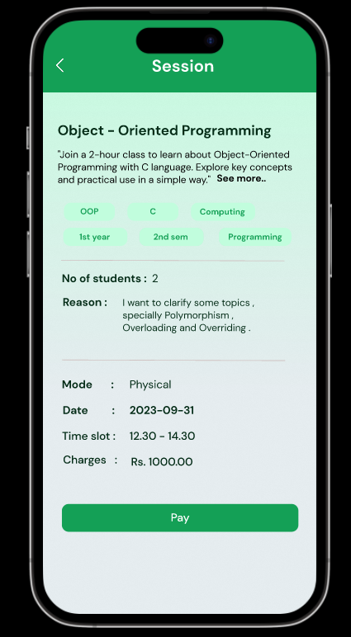

**Modification 02:**

* Changed color of the price tag for more clarity, based on the suggestion of interviewed user.

**Version 01 Version 02 (Modified Version)**

**Version 01 Version 02 (Modified Version)**

## IT21388934

**Modification 01:**

* Changed color of the price tag for more clarity, based on the suggestion of interviewed user.

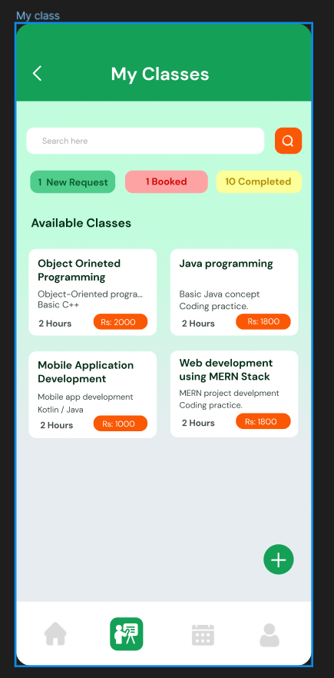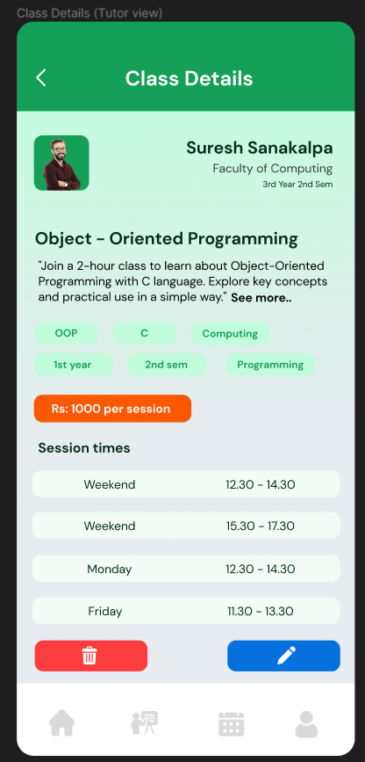**Version 01**

**Version 02 (Modified Version)**

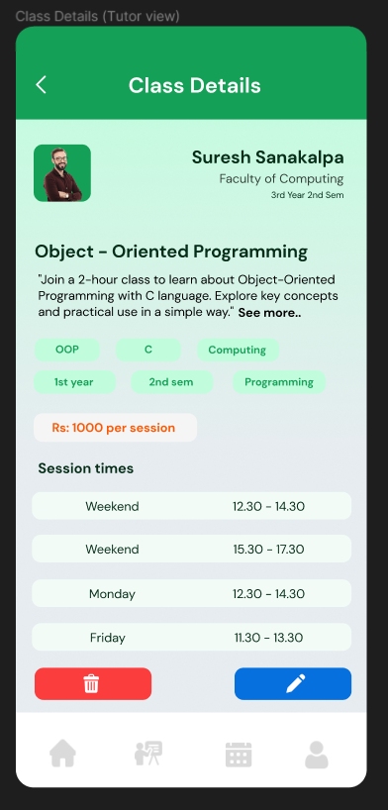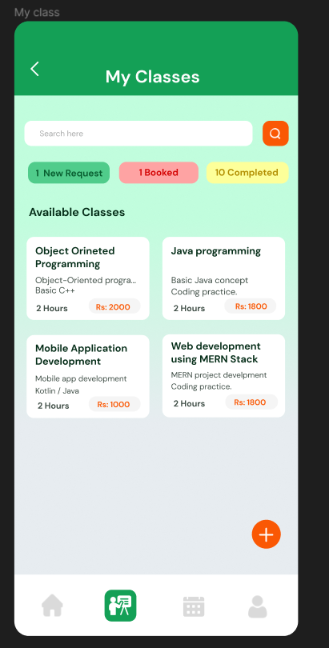

**Modification 02:**

* Remove decline, accept and send info button, to reduce the complexity and prevent accidental touch.

**Version 01**

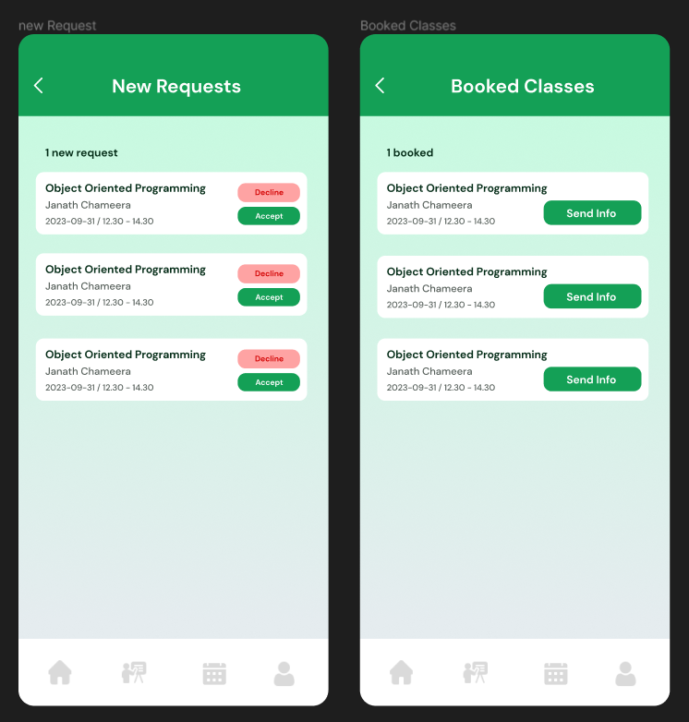

**Version 02 (Modified Version)**

